**Iteration 1 Planning**

Written Report

**Team 2**

Team Member:

Bhavsar, Dhruvit Vibhakar

Koshti, Khushboo

Lamichhane, Nishan

Liu, Ziyan

Virk, Ranvir

COMP231(Sec.007)

November 19, 2023

Professor : llir Dema

Centennial College

**Disaggregated tasks for home page:**

|  |  |  |  |
| --- | --- | --- | --- |
| **Constituent Task** | **Assigned Member** | **Expected Hours** | **Specific Functionality** |
| Header Design | Ziyan | 12 hours | Create a distinctive logo, design an intuitive navigation menu with categories, and ensure responsive behavior across various screen sizes. |
| CTA Elements | Nishan | 15 hours | Develop the real-time spending feature for the current month, ensuring it updates dynamically with each new transaction. |
| Income and Total Balance Section | Dhruvit | 11hours | Create a section below the spending display to show income and optional total balance, allowing user customization. |
| Performance Optimization | Ranvir | 13 hours | Implement three buttons at the bottom for spending categories, analytic reports, and adding new transactions, ensuring smooth redirection. |
| User Customization Feature | Khushboo | 14 hours | Develop a user customization feature allowing users to personalize the income and total balance display on the home page. |

**Disaggregated tasks for Add a new spending:**

|  |  |  |  |
| --- | --- | --- | --- |
| **Constituent Task** | **Assigned Member** | **Expected Hours** | **Specific Functionality** |
| Create UI Components | Khushboo | 15 hours | Develop an "Add a New Transaction" page with input fields for:  Amount of money spent  Category selection (e.g., food, rent, etc.)  Date of the transaction  Submit button for user confirmation |
| Backend Logic | Ranvir | 14 hours | Provide backend functionality so that input from users from the "Add a New Transaction" section may be received and processed. Make sure the information provided has been properly validated, regarding non-negative numbers and legitimate date formats. |
| Database Integration | Nishan | 12 hours | For storing the new spending transaction data, connect the capability with the database system.  Create the database structure with attributes like quantity, category, and timestamp to support spending events. |
| Return to Home Page selection | Ziyan | 10 hours | The user will be sent to the home page once a new spending transaction has been successfully added.  Merge the updated data into the monthly spending total displayed on the homepage. |
| User Feedback for transaction submission | Dhruvit | 12 hours | Use feedback messages or notifications to let the consumer know if the transaction submission was successful or unsuccessful.  If there are any sort of validation problems, provide messages of failure. |

**Disaggregated tasks for spending category Page:**

|  |  |  |  |
| --- | --- | --- | --- |
| **Constituent Task** | **Assigned Member** | **Expected Hours** | **Specific Functionality** |
| **Understanding Requirements** | Dhruvit | 8 hours | Conduct a thorough review of the user story and ensure a clear understanding of requirements. |
| **Designing Layout and Structure** | Ziyan | 14 hours | Develop an aesthetically pleasing and user-friendly interface for the Spending Category Page. |
| **Frontend Implementation** | Nishan | 16 hours | Implement frontend components for displaying spending categories. |
| **Backend Logic Implementation** | Ziyan | 18 hours | Develop backend logic for fetching and organizing spending data. |
| **Integration and Sorting** | Khushboo | 12 hours | Integrate frontend with backend, implement sorting functionality for spending data. |
| **Testing and Debugging** | Ranvir | 10 hours | Conduct rigorous testing and debugging to ensure a smooth user experience. |
| **Performance Optimization** | Dhruvit | 15 hours | Optimize the Spending Category Page for speed and responsiveness. |
| **Documentation and User Testing** | Ziyan | 10 hours | Create user documentation and conduct user testing for valuable feedback. |

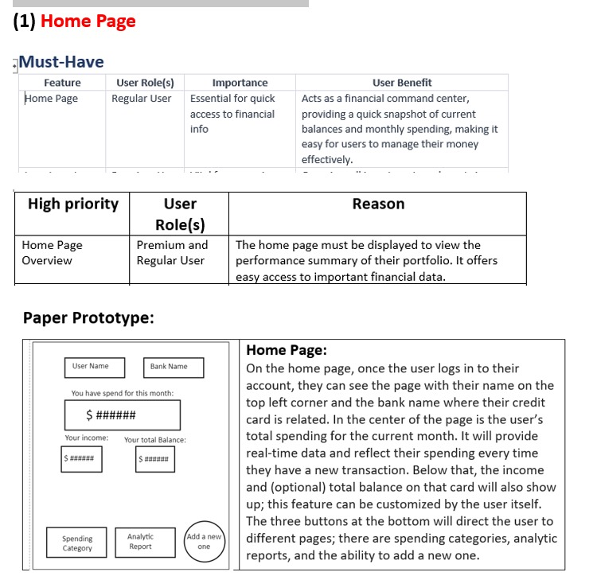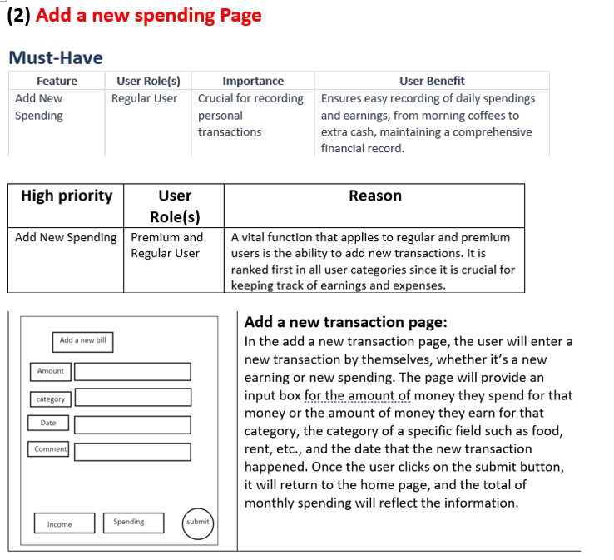

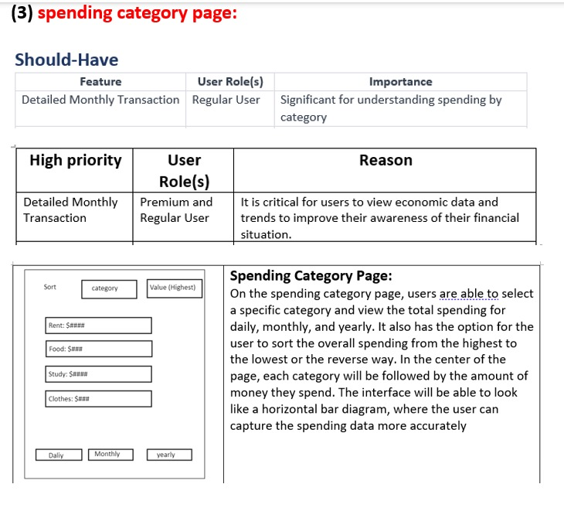

**Iteration Plan1:**

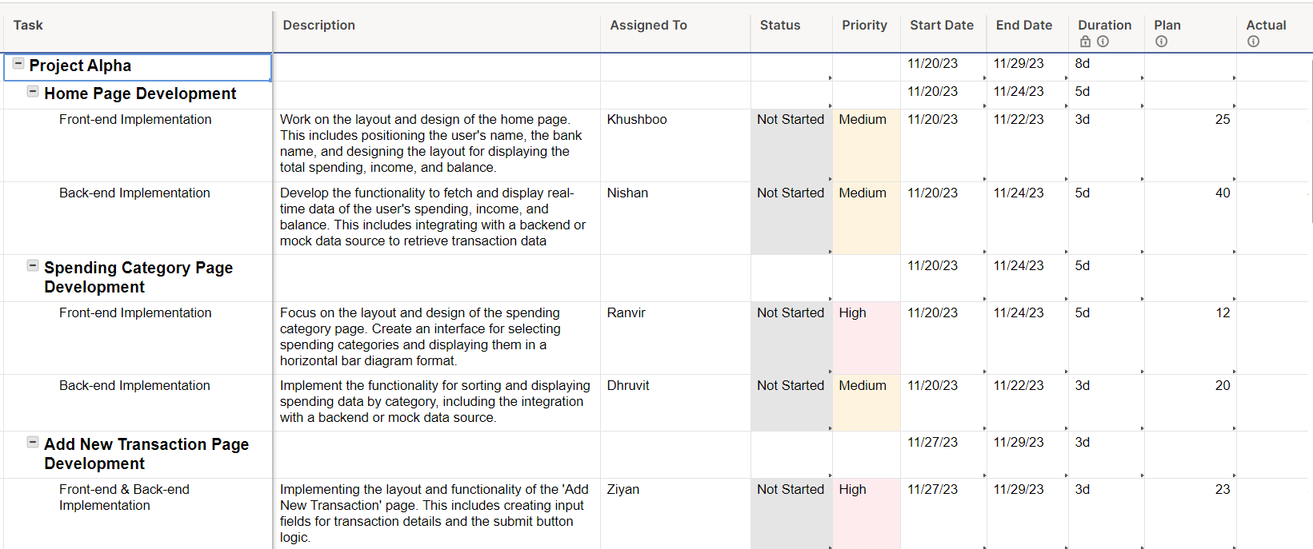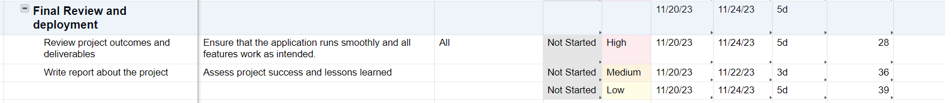

Gantt View:

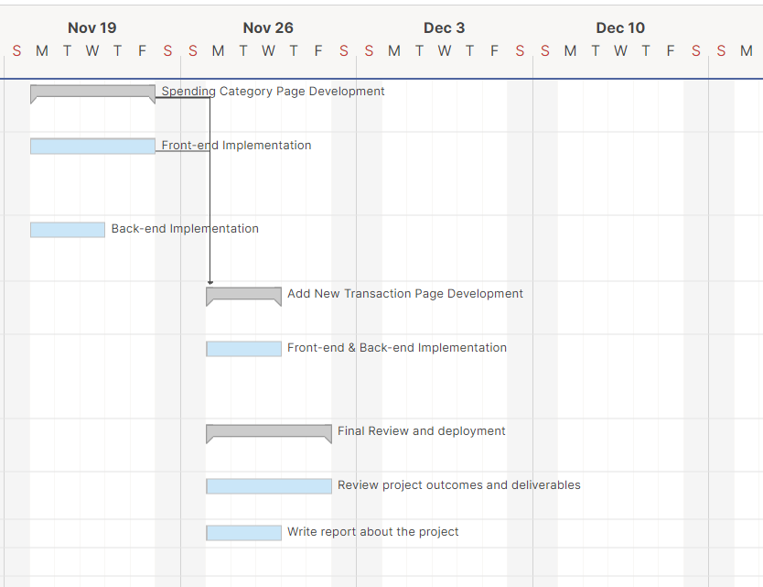

**Iteration Plan 2:**

**Iteration 1: Foundation and Core Features (Months 1-3)**

**1. Week 1-2: Project Setup and Planning**

**A.** Define project scope and gather requirements. **B.** Conduct market research.

**C.** Set up version control.

**2. Week 3-4: Core Development Environment and Database**

**A.** Establish core development environment. **B.** Define database schema.

**3. Week 5-6: User Authentication and Dashboard**

**A.** Implement user authentication. **B.** Create initial user dashboard.

**4. Week 7-9: Multi-Factor Authentication and OAuth Integration**

**A.** Implement MFA for security. **B.** Integrate OAuth.

**5. Week 10-12: Manual Data Entry and Basic Analytics**

**A.** Develop data entry form. **B.** Enable spending summary.

**Iteration 2: Data Integration & Enhanced Dashboard (Months 4-6)**

**6. Week 13-14: Data Import and Integration**

**A.** Implement data import. **B.** Integrate with financial platforms.

**7. Week 15-17: Customizable Metrics Dashboard**

**A.** Introduce customizable dashboard. **B.** Implement user-configurable layouts.

**8. Week 18-20: Data Security Measures**

**A.** Implement data encryption. **B.** Conduct security audits.

**9. Week 21-24: Category-wise Spending Analysis**

**A.** Enable transaction categorization. **B.** Provide visual expense breakdowns.

**Iteration 3: Automation & Alerts (Months 7-9)**

**10. Week 25-26: Scheduled Data Imports and Alerts**

**A.** Allow scheduled data imports. **B.** Implement automated alerts.

**11. Week 27-29: Performance Optimization**

**A.** Conduct performance testing. **B.** Optimize application speed.

**12. Week 30-32: User Interface Refinement**

**A.** Collect user feedback. **B.** Refine UI elements.

**Iteration 4: Collaboration & Reporting (Months 10-12)**

**13. Week 33-34: Custom Financial Report Generation**

**A.** Develop custom report feature. **B.** Include parameter options.

**14. Week 35-37: Collaboration Tools**

**A.** Introduce collaboration features. **B.** Implement user roles.

**15. Week 38-40: Export and Sharing**

**A.** Enable report export (PDF, CSV). **B.** Implement sharing options.

**16. Week 41-42: Evaluate and Implement Security Tools**

**A.** Evaluate and deploy vulnerability scanning. **B.** Explore Intrusion Detection Systems.